Master Data Management
Master and reference data management helps organizations effectively organize and access data. This aids in improving the customer experience, sales and revenue, continuous improvement, and streamlining processes. Due to the fragmented systems and manual processes, traditional organizations struggle to maintain high-quality data. Blockchain has been an accelerator in master data management. (Mckinsey & Company, 2024). Master data entities standardized values for data across systems. Customers, Supply chain, sales, and marketing data are a few examples of the data that must be managed for operational efficiency and data-driven decision-making.
Blockchain technology’s decentralized and immutable nature ensures data integrity, and security, and facilitates secure data sharing. Once recorded, records cannot be altered, and transactions are visible to all parties, reducing the risk of tampering. Blockchain technology reduces data siloes which leads to improved data reconciliation and adherence to compliance. By recording data in a tamper-proof ledger, blockchain ensures data integrity and traceability, making it an ideal solution for managing master and reference data.
Implementing this framework requires data collection and standardization, data integration, data quality management, data distribution and access, data governance and compliance. Figure 1 shows a visual implementation of the concept above.
Kenya is implementing blockchain technology in land registry management. This prevents fraud and ensures the accuracy of land ownership records (Maxwell Mwiti Mbae, 2024). South Africa uses it in the diamond supply chain to ensure the authenticity of diamonds (Filipe Calvaro & Victoria Gronwald, 2019). India has employed blockchain in healthcare where they securely manage patients records and maintain transparency and accurate historical records (Dr. Sriram & Parth Gupta, 2020). More examples are in real estate, education, and government records.
Blockchain technology offers a transformative approach to master and reference data management, addressing data quality and consistency. By leveraging blockchain, organizations can achieve more reliable and efficient data management, ensuring consistency and compliance across various domains.
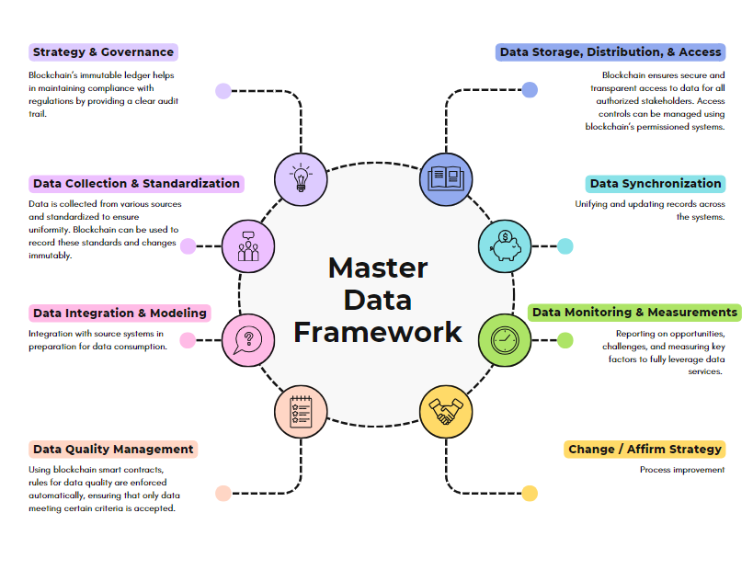

References
Dr. Sriram & Parth Gupta. (2020, January 22). Blockchain in Indian healthcare system. Forbes India. https://www.forbesindia.com/article/great-lakes-institute-of-management/blockchain-in-indian-healthcare-system/57281/1
Filipe Calvaro & Victoria Gronwald. (2019, August). Blockchain in the Mining Industry: Implications for Sustainable Development in Africa. SAIIA. https://saiia.org.za/wp-content/uploads/2019/09/Policy-Insights-74-calvao-gronwald.pdf
Maxwell Mwiti Mbae. (2024). Blockchain: Safeguarding Kenyan Land from Fraud. https://halandsurveys.africa/. https://halandsurveys.africa/the-future-of-land-administration-in-kenya-blockchain-technology/
McKinsey & Company. (2024, May 15). Master data management: The key to getting more from your data. https://www.mckinsey.com/capabilities/mckinsey-digital/our-insights/master-data-management-the-key-to-getting-more-from-your-data

